Student name : Vishnu T

Student Id : S181165200230

GitHub URL : [**https://github.com/Vishnuthamiz05**](https://github.com/Vishnuthamiz05)

**E-commerce website**

**Technology used:**

**Frontend**- HTML, CSS, BOOTSTRAP, Ajax.

**Middle ware-** java, Spring mvc, Hibernate.

**Backend-** H2 database.

**Versions used:**

Java version 1.8.0_91

maven version 3.5.0

Eclipse Neon

Tomcat 8.5

**HTML-**Hypertext Markup Language is the standard markup language for creating web pages and web applications.

**CSS-**Cascading Style Sheets is a style sheet language used for describing the presentation of a document written in a markup language.

**BOOTSTRAP-Bootstrap** is a free and open source front-end web framework for designing websites and web applications.

**ADVANTAGES**

* **Easy to use**
* **Responsive**
* **Browser compatibility**

**SPRING FRAMEWORK**

In Spring Web MVC, **DispatcherServlet** class works as the front controller. It is responsible to manage the flow of the spring mvc application.

And it is loosely coupled.

**HIBERNATE**

Hibernate framework simplifies the development of java application to interact with the database. Hibernate is an open source, lightweight, ORM (Object Relational Mapping) tool.

**H2 DATABASE**

H2 is a relational database management system written in Java. It can be embedded in Java applications or run in the client-server mode.

Basic operations:

|  |  |
| --- | --- |
| Admin operation: | Admin have seperate username password and can manage(edit, add, list, delete) the categories, suppliers details, and products. |
| User: | User can register as new user or can login using exist usrname and password. can see products and buy it. |
| Spring Security: | is a powerful and highly customizable authentication and access-control framework. |
| Add to cart: | products which are given as addtocart, does added to the user cart list |
| Webflow: | Spring Web Flow (SWF) is a component of the Spring Framework's web stack focused on the definition and execution of user interface (UI) flow within a web application. It is a module that allows you to make logical flows of your web application. |
| Multipart | Images upload feature using bytestream |

**Maven:**

It is a project management tool. Maven addresses two aspects of building software:

first, it describes how software is built, and second, it describes its dependencies management

It dynamically download java libraries and stores it in local cache

**Spring MVC flow**

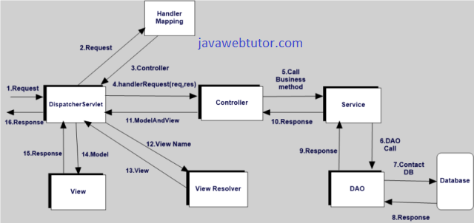

**Model** encapsulates the data related logic and it consist of POJO.

**View** is responsible for User interface logics, rendering the model data with webpage and generate output to the client browser to view page

**Controller** process all business logic and handles responses and request between model & view

* The flow starts from, when the client gives a request via url
* Dispatcher servlet which is called as front controller, receive the http request
* Using Handler Mapping, and call the appropriate controller associated with request
* Controller process the request by calling service methods and return ModelAndView
* ModelAndView object contains model data and view page name to dispatcher servlet
* With ViewResolver the prefix and suffix properties of viewpage appended to page name
* And With View interface renders the object to webpage
* Finally dispatcher servlet sent the view page to User

**List of jars used and its versions:**

spring-core: 4.3.5.RELEASE

spring-context:4.3.5.RELEASE

spring-webmvc:4.3.5.RELEASE

jstl:1.2

javax.servlet-api:3.1.0

junit:3.8.1[test]

h2:1.4.193

hibernate-core:5.2.5.Final

hibernate-jpa-2.1-api:1.0.0.Final

spring-orm:4.3.3.RELEASE

spring-web:4.3.5.RELEASE

validation-api:1.1.0.Final

hibernate-validator:5.3.4.Final

spring-beans:4.3.5.RELASE

spring-security-config:4.1.4.Final

spring-security-taglibs:4.1.4.Final

spring-security-web:4.2.1.RELEASE

commons-fileupload:1.3.2

commons-io:2.5

commons-dbcp2:2.0

spring-webflow:2.4.4.RELAESE